**תרגיל 3**

שמות המגישים :

אמיר קפלן – 208789172

תום שליים - 318734845

פירוט אודות רשימת הטיפוסים :

**ConsoleUI :**

1. **eGarageFunctions** – An enum that holds the permitted garage functions (such as adding a new vehicle, show specific vehicle data, change vehicle status in the garage etc.)
2. **GarageUI** – A class that runs the garage logic, based on the requested functions that are given as input from the user. This class operates the GarageManager function on the GarageLogic project.
3. **MessagesGenerator** – A class that holds generic function for useful console printing.
4. **Program** – A class that constitute the starting point of the whole project.
5. **UIValidator** – A class that holds UI specific validations (such as the validation for the chosen garage function by the user).

**GarageLogic :**

1. **Car** – A class that holds car specific data (such as color, number of doors etc.).
2. **eCarColor** – An enum that holds the possible car colors.
3. **eFuelType** – An enum that holds the possible fuel types.
4. **ElectricEngine** – A class that derives from the Engine class and handles the logic behind the electric engine (such as recharging the battery).
5. **eLicenseType** – An enum that holds the possible license types.
6. Engine – An abstract class that holds shared members and methods with the FuelEngine and the ElectricEngine classes.
7. **eNumOfDoors** – An enum that holds the possible number of doors.
8. **eVehicleStatus** – An enum that holds the possible statuses of the vehicle in the garage.
9. **eVehicleType** – An enum that holds the possible vehicle types.
10. **FuelEngine** – A class that derives from the Engine class and handles the logic behing the fuel engine (such as refuel).
11. **GarageManager** – A class that handles the logic behind the garage and is executed by the GarageUI. It also operates the VehicleGenerator class.
12. **GarageVehicleInfo** – A class that holds the necessary info for a vehicle in the garage (Vehicle, VehicleOwner, VehicleStatus).
13. **LogicValidator** – A class that handles the validations to some of the user input.
14. **Motorcycle** – A class that holds motorcycle specific data (such as license type, engine volume etc.).
15. **Truck** - A class that holds truck specific data (such as is carrying dangerous materials, cargo volume etc.).
16. **ValueOutOfRangeException** – A class that derives from the Exception class and throws a specific error for cases in which the given value is out of the set range.
17. **Vehicle** – An abstract class that holds shared members and methods with the Car, Motorcycle and Truck classes. It also has capabilities to edit its wheels.
18. **VehicleGenerator** – A class that generates vehicles, updates their fields, and set the fields that need to be set per vehicle type (This function is used indirectly by the GarageUI class, using the GarageManager class).
19. **VehicleOwner** – A class that holds the owner needed data (Name and phone number).
20. **Wheel** – A class that holds wheel data (such as manufacturer, current air pressure etc.).
21. **eVehicleAdditionalFields** – An enum that holds all the additional fields to be populated for all vehicle types.

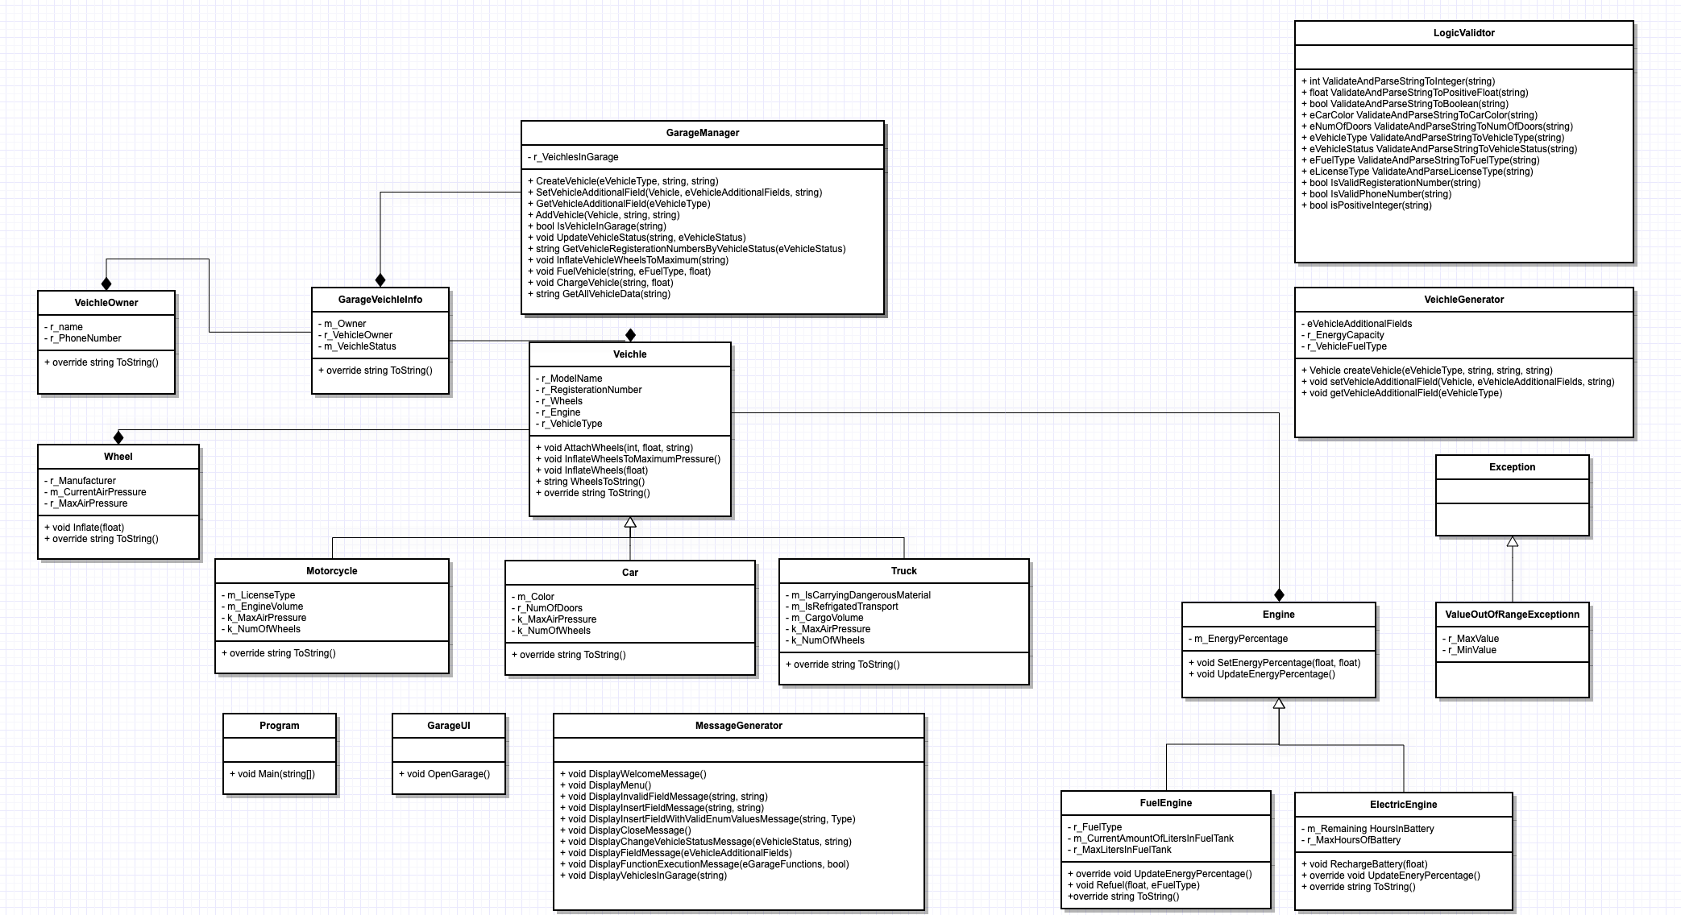דיאגרמה :